1.Open the Windows Defender Security Center on your laptop or desktop and take a screenshot showing the status of Virus & Threat Protection, Firewall & Network Protection, and App & Browser Control.
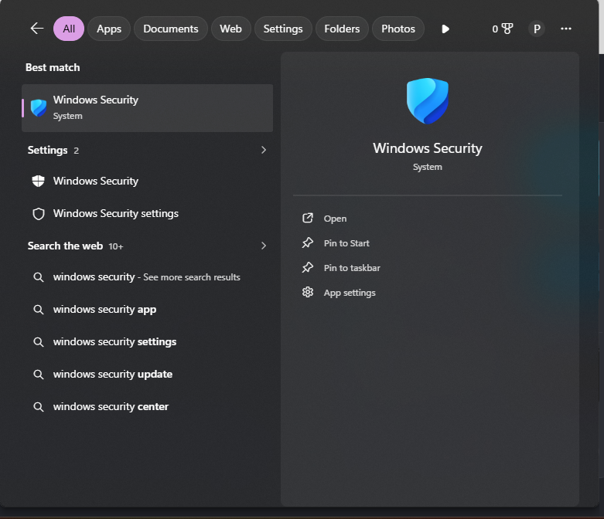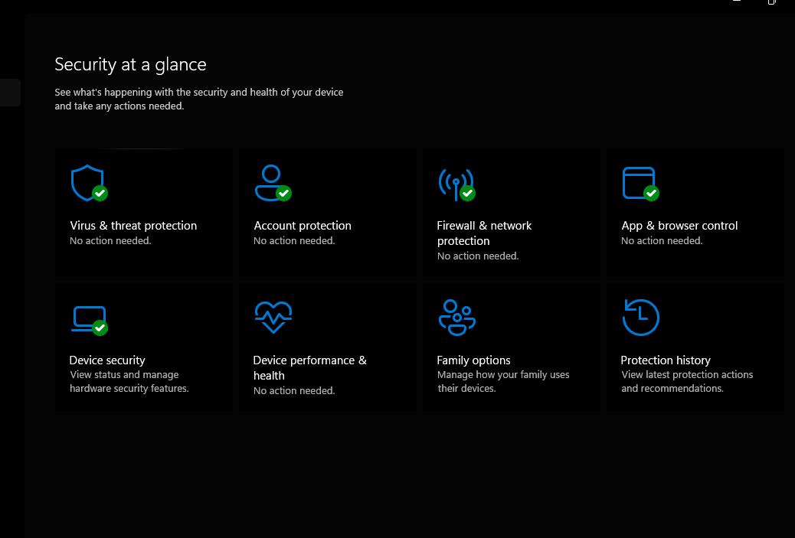
2.Create a new user account on your Windows system and set a strong password that meets at least 3 out of 4 complexity requirements (uppercase, lowercase, number, special character).
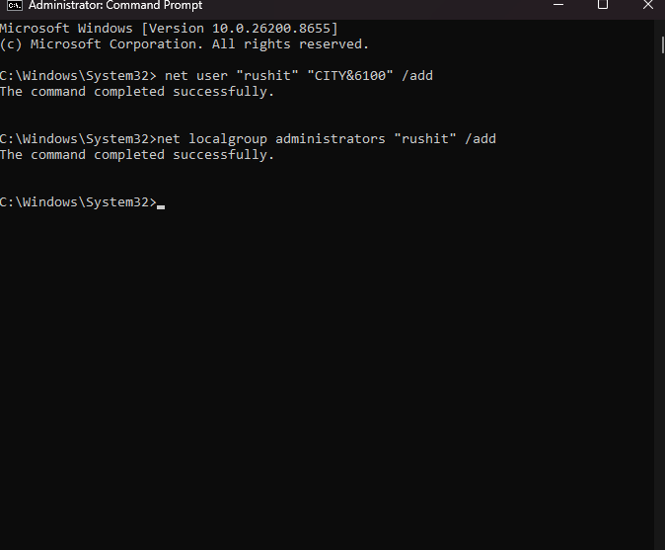
3.Disable file sharing for the Public folder in Windows and verify that it is no longer accessible from another device on the same network.<br><br><em><strong>Hint:</strong> Use the 'Advanced sharing settings' in the Network and Sharing Center.</em>
To disable Public folder sharing in Windows 11 or Windows 10, you must turn off the network discovery setting that allows other devices to view those public files.
Part 1: Disable Public Folder Sharing
- Press the Windows Key, type Control Panel, and press Enter.
- Click on Network and Internet, then select Network and Sharing Center.
- In the left sidebar, click Change advanced sharing settings.
- Expand the All Networks profile section by clicking the drop-down arrow.
- Locate Public folder sharing and select the option to Turn off Public folder sharing.
- Click Save changes at the bottom of the window.
Part 2: Verify It Is No Longer Accessible
To ensure the folder is completely locked down, verify the restriction from a second device (like a laptop or smartphone) connected to the same Wi-Fi network:
- Open the file explorer on the secondary device.
- In the address bar, type your main computer's network path (\\YourComputerName or \\Your-IP-Address) and press Enter.
- The Result: The Public folder will either be completely missing from the network directory, or double-clicking it will trigger a "Windows cannot access... You do not have permission" network error.

4.Configure the Windows Firewall to block all incoming connections for a specific app of your choice (for example, Spotify or Chrome) and test that the app cannot access the internet.<br><br><em><strong>Hint:</strong> Go to Windows Defender Firewall > Allow an app or feature through Windows Defender Firewall, and adjust the settings.</em>
Part 1: Block the App in Windows Firewall
- Press the Windows Key, type Control Panel, and press Enter.
- Click on System and Security, then select Windows Defender Firewall.
- In the left-hand menu, click the link that says Allow an app or feature through Windows Defender Firewall.
- Click the Change settings button at the top right (you may need administrator permission).
- Scroll down the list until you locate your chosen app (e.g., Google Chrome or Spotify).
- Uncheck all checkboxes (Private and Public) next to the app's name to revoke its network permissions.
- Click OK at the bottom of the window to apply the new security rule.
Part 2: Test and Verify the Block
Once you click save, the firewall rules apply immediately. Open the app you just restricted to confirm the internet block is active:
- If you blocked Chrome: Open a new browser tab and try to load a live website like google.com. The browser will fail to load the page and will display a network error like "ERR_NETWORK_CHANGED" or "Your internet access is blocked".
- If you blocked Spotify: Open the app and try to stream a new song or search for an artist. The app will display an "Offline" banner at the bottom or show a loading wheel that never connects.
If the app is still managing to connect to the internet, let me know if you would like to:
- Use Windows Firewall with Advanced Security to create an explicit, airtight Outbound Rule.
- Find the exact executable path (.exe) of the app if it isn't showing up in the default list.
- Learn how to reset your firewall back to its original factory settings.

